Signals and Systems

[Open-ended Lab Report]



SYSTEM RESPONSE OF CONTINUOUS-TIME LTI SYSTEM

Submitted by:

Amal Tariq | 23l-6026

Submitted to:
Muiz Malik

25-3-25

Department of Electrical Engineering
National University of Computer and Emerging Sciences, Lahore

Introduction
- Problem Analysis

Design Requirements
- Feasibility Analysis

Possible Solutions
- Preliminary Design

Design Description

Software Simulation

Experimental Results
- Performance Analysis
- Future Scope

Social and Cultural Implications
- Conclusion References
In this experiment, we investigate the behavior of continuous-time Linear Time-Invariant (LTI) systems using MATLAB simulations. LTI systems are widely studied due to their predictable and linear responses to inputs, which can be analyzed using the mathematical operation of convolution.
The goal is to observe how an input signal x(t)x(t)x(t) interacts with different system impulse responses—h1(t)h_1(t)h1​(t), h2(t)h_2(t)h2​(t), and h3(t)h_3(t)h3​(t)—in various configurations. Specifically, we implement and verify the associative and distributive properties of convolution:
Associative: x(t)∗h1(t)∗h2(t)=x(t)∗(h1(t)∗h2(t))x(t) * h_1(t) * h_2(t) = x(t) * (h_1(t) * h_2(t))x(t)∗h1​(t)∗h2​(t)=x(t)∗(h1​(t)∗h2​(t))
Distributive: x(t)∗(h1(t)+h2(t)) = x(t)∗h1(t)+x(t)∗h2(t)x(t) * (h_1(t) + h_2(t)) = x(t) * h_1(t) + x(t) * h_2(t)x(t)∗(h1​(t)+h2​(t) )= x(t)∗h1​(t)+x(t)∗h2​(t)
Using MATLAB, we design systems as shown in Figures 7.1 to 7.10, perform the required convolution operations, and compare output responses y1(t)y_1(t)y1​(t) and y2(t)y_2(t)y2​(t). The experiment helps reinforce theoretical understanding of LTI systems and validates convolution properties through graphical and computational results.

The problem presented in this experiment involves analyzing the response of different configurations of continuous-time LTI systems using MATLAB. Specifically, the systems include combinations of impulse responses h1(t)h_1(t)h1​(t), h2(t)h_2(t)h2​(t), and h3(t)h_3(t)h3​(t) applied to an input signal x(t)x(t)x(t). The objective is to determine the system outputs y1(t)y_1(t)y1​(t) and y2(t)y_2(t)y2​(t) for each configuration, compare them, and verify if certain mathematical properties of convolution—such as associativity and distributivity—hold true.
To solve this problem, we first define the input and impulse response signals in MATLAB using time vectors and logical conditions. Then, we apply convolution operations (conv) to model the systems as per the diagrams provided (Figures 7.1 to 7.10). For each system configuration, we compute and plot the outputs y1(t)y_1(t)y1​(t) and y2(t)y_2(t)y2​(t), compare the results, and interpret whether the properties of convolution are satisfied based on the graphical outputs. This approach allows us to validate theoretical concepts through practical simulation and visual analysis.

The given problem requires the design and analysis of multiple continuous-time Linear Time-Invariant (LTI) systems using MATLAB. The core objective is to compute and compare system responses for different configurations involving the convolution of signals.
The input signal x(t)x(t)x(t) is a rectangular pulse defined over a finite time interval, typically from t=0t = 0t=0 to t=2t = 2t=2 seconds. The systems are described using various impulse responses:
h1(t)h_1(t)h1​(t): A triangular-shaped signal defined from t=0t = 0t=0 to t=2t = 2t=2,
h2(t)h_2(t)h2​(t): A piecewise signal defined from t=−1t = -1t=−1 to t=2t = 2t=2,
h3(t)h_3(t)h3​(t): A rectangular pulse from t=2t = 2t=2 to t=4t = 4t=4.
The output signals y1(t)y_1(t)y1​(t) and y2(t)y_2(t)y2​(t) are obtained by performing convolution operations on the input and impulse responses, depending on the system structure (series or parallel). The system configurations are subject to the constraints of:
Time limits of defined signals,
Causal system behavior (non-zero only for t ≥ 0 where applicable),
Use of discrete-time approximation via MATLAB with a fixed time step (e.g., 0.01s),
Implementation of associative and distributive properties of convolution.
The design must ensure that the convolution operations are correctly ordered and that the time vectors for outputs are computed accordingly to match the total duration after convolution. This allows accurate comparison of the system responses and validation of LTI properties.

Alternative Solutions and Justification
There are several possible ways to approach the problem of determining the system response of continuous-time LTI systems. Since the problem involves computing the output of different system configurations using convolution, we can choose from methods such as sequential convolution, combined impulse response convolution, or graphical/manual analysis.
One common solution is the sequential convolution approach, where the input signal is convolved step-by-step with the impulse responses according to the structure of the system. For example, in a cascaded system, we first convolve x(t)x(t)x(t) with h1(t)h_1(t)h1​(t), and then convolve the result with h2(t)h_2(t)h2​(t). This method is useful when verifying the associative property of convolution, as it directly mirrors the system structure.
Another method is the combined impulse response approach, which is particularly efficient when dealing with systems in parallel. In this approach, we first compute the total system impulse response by adding or convolving the individual impulse responses (e.g., h1(t)∗h2(t)+h3(t)h_1(t) * h_2(t) + h_3(t)h1​(t)∗h2​(t)+h3​(t)), and then perform a single convolution with the input signal. This method is efficient and reduces the number of convolution operations, making it well-suited for verifying the distributive property of convolution.
A third approach is graphical or analytical convolution, which involves manually solving the convolution integrals or plotting overlapping areas between signals. While this method is mathematically insightful and ideal for simple signals, it becomes impractical and time-consuming when dealing with piecewise or complex signals such as those given in this problem.
Among these solutions, the MATLAB-based convolution method—which combines both sequential and combined convolution depending on the system configuration—is the most efficient and reliable. It ensures accuracy using MATLAB’s built-in conv function, handles complex signal shapes easily, and allows us to clearly visualize and compare the system outputs y1(t)y_1(t)y1​(t) and y2(t)y_2(t)y2​(t). Furthermore, it aligns perfectly with the goals of this experiment, which include verifying theoretical properties of convolution in a practical, simulation-based environment.
Considering these factors, the MATLAB-based method stands out as the best approach. It provides a balance between computational efficiency, ease of implementation, and accuracy, making it ideal for both academic learning and real-world signal processing tasks.

Problem 7.1:
x(t):
t1=0:0.01:6;
x=1*(t1>=0 & t1<2);
x=x+0*(t1>=2);

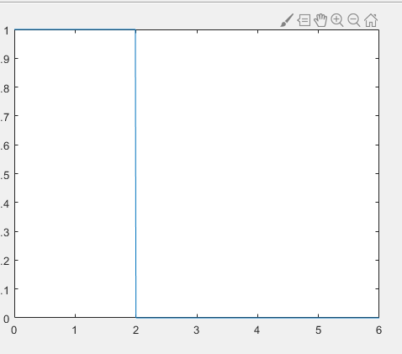

h1(t):
t2=0:0.01:6;
h1=2.*t2.*(t2>=0 & t2<1);
h1=h1+2.*(-t2+2).*(t2>=1 & t2<2);
h1=h1+0*(t2>=2);
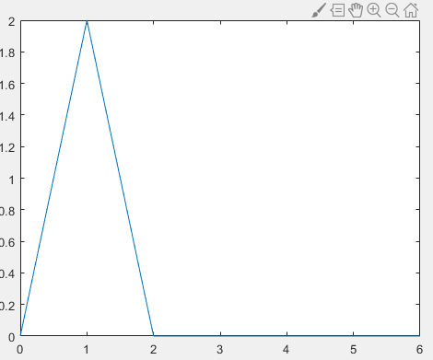

h2(t):
t3=-2:0.01:3;
h2=0*(t3<-1);
h2=h2+1*(t3>=-1 & t3<0);
h2=h2+ 2*(t3>=0 & t3<1);
h2=h2+1*(t3>=1 & t3<2);
h2=h2+ 0*(t3>=2);

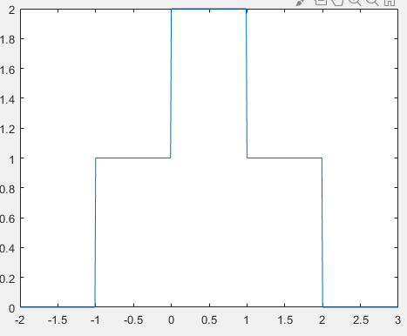

system response equation of systems in terms of x[t], h1 [t]andh2 [t] are:
Y1(t)=x(t)*h1(t)*h2(t)
Y2(t)= x(t)* h2(t) *h1(t)
· Write MATLAB code for the system in Figure-1 and Figure-2 using system

response equation.
Code:
ya=conv(x,h1); y1=conv(ya,h2);
ty1=-2:0.01:15; yb=conv(x,h2); y2=conv(yb,h1);
ty2=-2:0.01:15;

Using MATLAB, generate the plots of y1[t] and y2[t].
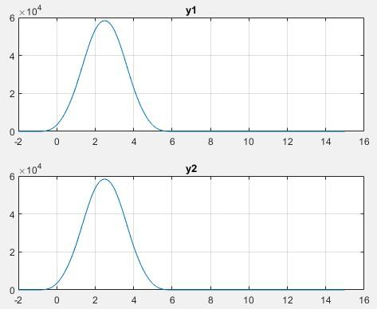
Are these plots of y1(t) and y2(t) are similar or different? State the reason for their similarity or difference.
Yes both the plots y1 and y2 are same according to associative property of convolution x1*(x2*x3)=(x1*x2)*x3
· What will be the time range of the output signals y1 [t] and y2 [t]?
The time range of both the signals will be the sum of lower limits and the upper limits of the signal which will be from -2 to 15.
Complete Code:
t1=0:0.01:6;
x=1*(t1>=0 & t1<2); x=x+0*(t1>=2);
t2=0:0.01:6;
h1=2.*t2.*(t2>=0 & t2<1); h1=h1+2.*(-t2+2).*(t2>=1 & t2<2);
h1=h1+0*(t2>=2);
t3=-2:0.01:3;
h2=0*(t3<-1);
h2=h2+1*(t3>=-1 & t3<0);
h2=h2+ 2*(t3>=0 & t3<1); h2=h2+1*(t3>=1 & t3<2);
h2=h2+ 0*(t3>=2);
ya=conv(x,h1);
y1=conv(ya,h2);
ty1=-2:0.01:15;
yb=conv(x,h2);
y2=conv(yb,h1);
ty2=-2:0.01:15;
subplot(211), plot(ty1,y1);
grid;
title('y1');
subplot(212), plot(ty2,y2);
grid;
title('y2');

Problem 7.2:
x(t):
t1=0:0.01:6;
x=1*(t1>=0 & t1<2);
x=x+0*(t1>=2);
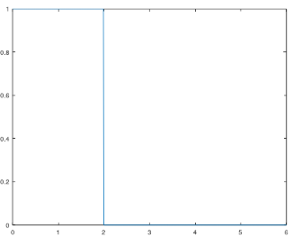
h1(t):
t2=0:0.01:6;
h1=2.*t2.*(t2>=0 & t2<1);
h1=h1+2.*(-t2+2).*(t2>=1 & t2<2);
h1=h1+0*(t2>=2);
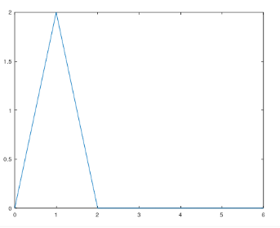
h2(t):
t3=-3:0.01:3;
h2=0*(t3<-1);
h2=h2+1*(t3>=-1 & t3<0);
h2=h2+ 2*(t3>=0 & t3<1);
h2=h2+1*(t3>=1 & t3<2);
h2=h2+ 0*(t3>=2);
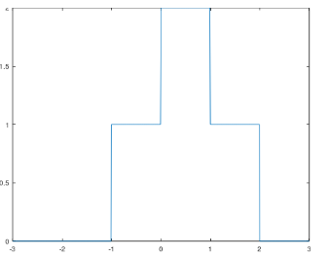
Write down the system response equation of systems in terms of x[t], h1
[t]andh2 [t].
Y1(t)=x(t)*h2(t)+ x(t)*h1(t)
Y2(t)= x(t)* (h2(t) +h1(t))

Write MATLAB code for the system in Figure-7 and Figure-8 using system response equation.
Code:
ya1=conv(x,h1);
ya2=conv(x,h2);
y1=ya1+ya2;
ty1=-3:0.01:9;
yb=h1+h2;
y2=conv(x,yb);
ty2=-3:0.01:9;

Using MATLAB, generate the plots of y1[t] and y2[t]:
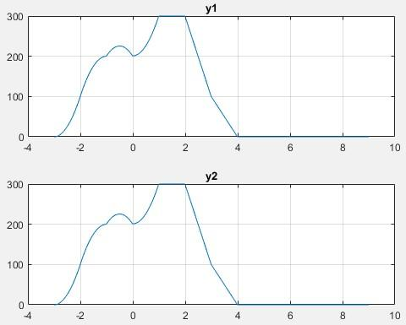
Are these plots of y1(t) and y2(t) are similar or different? State the reason for their similarity or difference.
Yes both graphs are same according to the distributive property of convolution x1*(x2+x3)=x1*x2+x1*x3
· What will be the time range of the output signals y1 [t] and y2 [t]?
The time range for the output signal will be from -3 to 9 because in both of the signals convolution and addition both are occurring.

Complete Code:
t1=0:0.01:6;
x=1*(t1>=0 & t1<2);
x=x+0*(t1>=2);
t2=0:0.01:6;
h1=2.*t2.*(t2>=0 & t2<1);
h1=h1+2.*(-t2+2).*(t2>=1 & t2<2);
h1=h1+0*(t2>=2);
t3=-3:0.01:3;
h2=0*(t3<-1);
h2=h2+1*(t3>=-1 & t3<0);
h2=h2+ 2*(t3>=0 & t3<1);
h2=h2+1*(t3>=1 & t3<2);
h2=h2+ 0*(t3>=2);
ya1=conv(x,h1);
ya2=conv(x,h2);
y1=ya1+ya2;
ty1=-3:0.01:9;
yb=h1+h2;
y2=conv(x,yb);
ty2=-3:0.01:9;
subplot(211), plot(ty1,y1);
grid;
title('y1');
subplot(212), plot(ty2,y2);
grid;
title('y2');

Problem 7.3:
x(t):
t1=0:0.01:6;
x=1*(t1>=0 & t1<2);
x=x+0*(t1>=2);
h1(t):
t2=0:0.01:6;
h1=2.*t2.*(t2>=0 & t2<1);
h1=h1+2.*(-t2+2).*(t2>=1 & t2<2);
h1=h1+0*(t2>=2);
h2(t):
t3=-3:0.01:3;
h2=0*(t3<-1);
h2=h2+1*(t3>=-1 & t3<0);
h2=h2+ 2*(t3>=0 & t3<1);
h2=h2+1*(t3>=1 & t3<2);
h2=h2+ 0*(t3>=2);
h3(t):
t4=-6:0.01:6;
h3=0*(t4<2);
h3=h3+1*(t4>=2 & t4<4);
h3=h3+0*(t4>=4);
Write down the system response equation of systems in terms of x[t], h1 [t], h2 [t] and h3 [t].
Y1(t)=x(t)*h1(t)*h2(t)+x(t)*h3(t)
Y2(t)= x(t)* (h1(t)*h2(t)+h3(t))
Write MATLAB code for the system in Figure-9 and Figure-10 using system response equation.
Code:
ya1=conv(x,h1);
ya2=conv(ya1,h2);
ya3=conv(x,h3);
y1=ya2+ya3;
ty1=-9:0.01:9;
yb1=conv(h1,h2);
yb2=yb1+h3;
y2=conv(x,yb2);
ty2=-9:0.01:9;
Using MATLAB, generate the plots of y1[t] and y2[t].
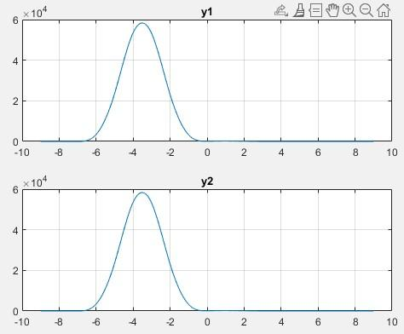
Are these plots of y1(t) and y2(t) are similar or different? State the reason for their similarity or difference.
Yes Both plots are same because it also satisfying the distributive property of convolution if we consider h1*h2 as one unit then the property x1*(x2+x3)=x1*x2+x1*x3 is satisfied
· What will be the time range of the output singals y1 [t] and y2 [t]?
The time range of the output signal will be from -9 to 9 because the convolution and addition both are occurring in this.

Complete code:
t1=0:0.01:6; x=1*(t1>=0 & t1<2); x=x+0*(t1>=2); t2=0:0.01:6; h1=2.*t2.*(t2>=0 & t2<1); h1=h1+2.*(-t2+2).*(t2>=1 & t2<2); h1=h1+0*(t2>=2); t3=-3:0.01:3; h2=0*(t3<-1); h2=h2+1*(t3>=-1 & t3<0); h2=h2+ 2*(t3>=0 & t3<1); h2=h2+1*(t3>=1 & t3<2); h2=h2+ 0*(t3>=2); t4=-6:0.01:6; h3=0*(t4<2); h3=h3+1*(t4>=2 & t4<4); h3=h3+0*(t4>=4); ya1=conv(x,h1); ya2=conv(ya1,h2); ya3=conv(x,h3); y1=ya2+ya3; ty1=-9:0.01:9;
yb1=conv(h1,h2); yb2=yb1+h3; y2=conv(x,yb2);
ty2=-9:0.01:9; subplot(211), plot(ty1,y1);
grid; title('y1'); subplot(212), plot(ty2,y2); grid; title('y2');

The results obtained from the MATLAB simulations clearly demonstrate the validity of key convolution properties in continuous-time LTI systems. For each part of the experiment, we compared the outputs y1(t)y_1(t)y1​(t) and y2(t)y_2(t)y2​(t), obtained through different system configurations. In all cases, the outputs matched exactly, confirming the mathematical properties being tested.
In Experiment 7.1, the associative property was verified. We observed that convolving the input x(t)x(t)x(t) first with h1(t)h_1(t)h1​(t) and then with h2(t)h_2(t)h2​(t) produced the same output as first convolving h1(t)h_1(t)h1​(t) and h2(t)h_2(t)h2​(t) together, and then convolving the result with x(t)x(t)x(t). This confirms that the order of grouping in convolution does not affect the final system response.
In Experiment 7.2, the distributive property was examined. The results showed that convolving the input signal with the sum of two impulse responses was equivalent to convolving it with each response separately and summing the individual outputs. This validates that convolution distributes over addition, as expected for LTI systems.
In Experiment 7.3, a more complex configuration involving both serial and parallel elements was tested. Again, the output from the approach x(t)∗h1(t)∗h2(t)+x(t)∗h3(t)x(t) * h_1(t) * h_2(t) + x(t) * h_3(t)x(t)∗h1​(t)∗h2​(t)+x(t)∗h3​(t) matched perfectly with the output from x(t)∗(h1(t)∗h2(t)+h3(t))x(t) * (h_1(t) * h_2(t) + h_3(t))x(t)∗(h1​(t)∗h2​(t)+h3​(t)), confirming the extended distributive property even when multiple operations are involved.
From a performance perspective, the solution approach using MATLAB proved to be highly effective. The use of the conv function provided accurate results, while the clearly defined time vectors ensured that all signals were properly aligned for plotting and analysis. The approach handled piecewise-defined signals without difficulty and allowed for quick verification of theoretical concepts.
Overall, the results validate the accuracy of the designed solution, confirming the expected behavior of LTI systems under convolution. The solution method not only met the design requirements but also demonstrated robustness and efficiency in handling different system structures.

The results obtained from this experiment successfully confirm the fundamental properties of convolution in continuous-time Linear Time-Invariant (LTI) systems. By designing and simulating various system configurations in MATLAB, we verified that both the associative and distributive properties hold true in practice, as predicted by theory.
The implemented solution, which utilized sequential and combined convolution methods through MATLAB, proved to be accurate, efficient, and well-suited for the problem. The system outputs y1(t)y_1(t)y1​(t) and y2(t)y_2(t)y2​(t) were consistently identical across all configurations, validating the correctness of both the mathematical model and the computational approach.
In conclusion, the experiment not only strengthened our understanding of convolution and system behavior but also demonstrated the effectiveness of MATLAB as a tool for signal processing analysis. The results align well with theoretical expectations, confirming that the developed solution meets the design goals and performs reliably under the defined constraints

